**Group Project 15 – Design Specification**

|  |  |
| --- | --- |
| **Authors:** | **Imran Mungul, Kamil Mrowiec, Fiona Joseph Samy, Sam Sherar** |
| **Config Ref:** | **SE_15_DESIGN_01** |
| **Date** | **14th February 2013** |
| **Version** | **1.3** |
| **Status** | **Final** |

|  |
| --- |
| **Department of Computer Science**  **Aberystwyth University**  **Aberystwyth**  **Ceredigion**  **SY23 3DB**  **Copyright © Aberystwyth University 2012** |

Table of Contents

Introduction 3

Purpose of this Document 3

Scope 3

Objectives 3

Decomposition Description 4

Class Diagram 4

Class Description 7

Mapping from requirements to Classes 8

Dependency Description 9

Component Diagrams 9

Detailed Design 10

Sequence Diagrams 10

Change log 16

# Introduction

## Purpose of this Document

The purpose of this document was to provide an insight as to how we proceeded in creating the diagrams required for the group project we had been assigned to do. This document will present to you all the information, from descriptions to designs, which “Group 15” had created in regards to the design aspect of this project.

## Scope

This document shows all the diagrams, methods and descriptions regarding the design factor of this project. It reveals how the diagrams all inter-link to each other from the server side to the design. The descriptions of the classes used are clearly explained in this document, as well as the methods we had used, to give you an understanding of how we progressed in this assignment.

## Objectives

The priority objective for the design team was to create the necessary resources for the application to the point that it worked efficiently, as well as having an impressive appearance. The software structure, components, interfaces and the data revolving around the design factors would all have to be drawn up and created by the team ensuring it meets the requirements of the group as a whole.

# Decomposition Description

## Class Diagram

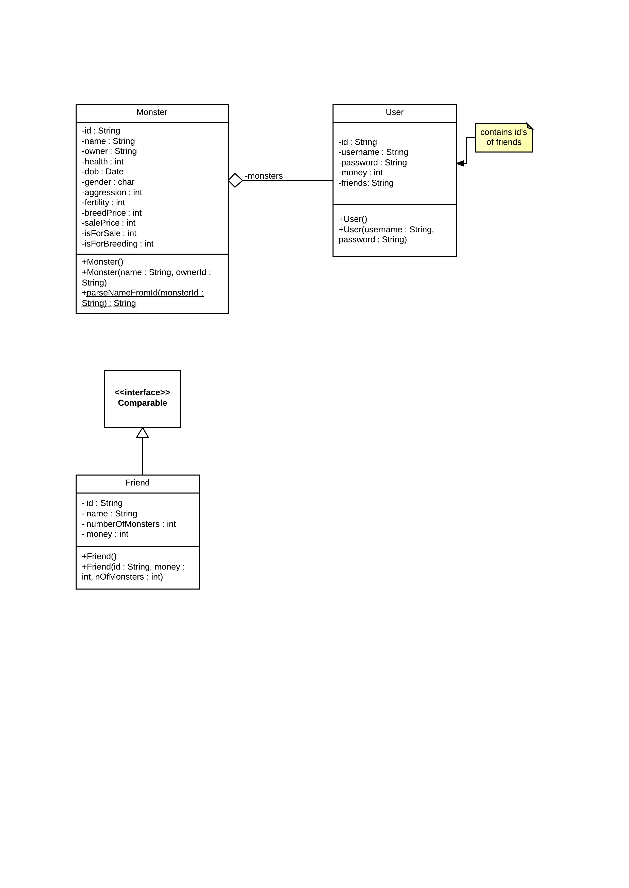

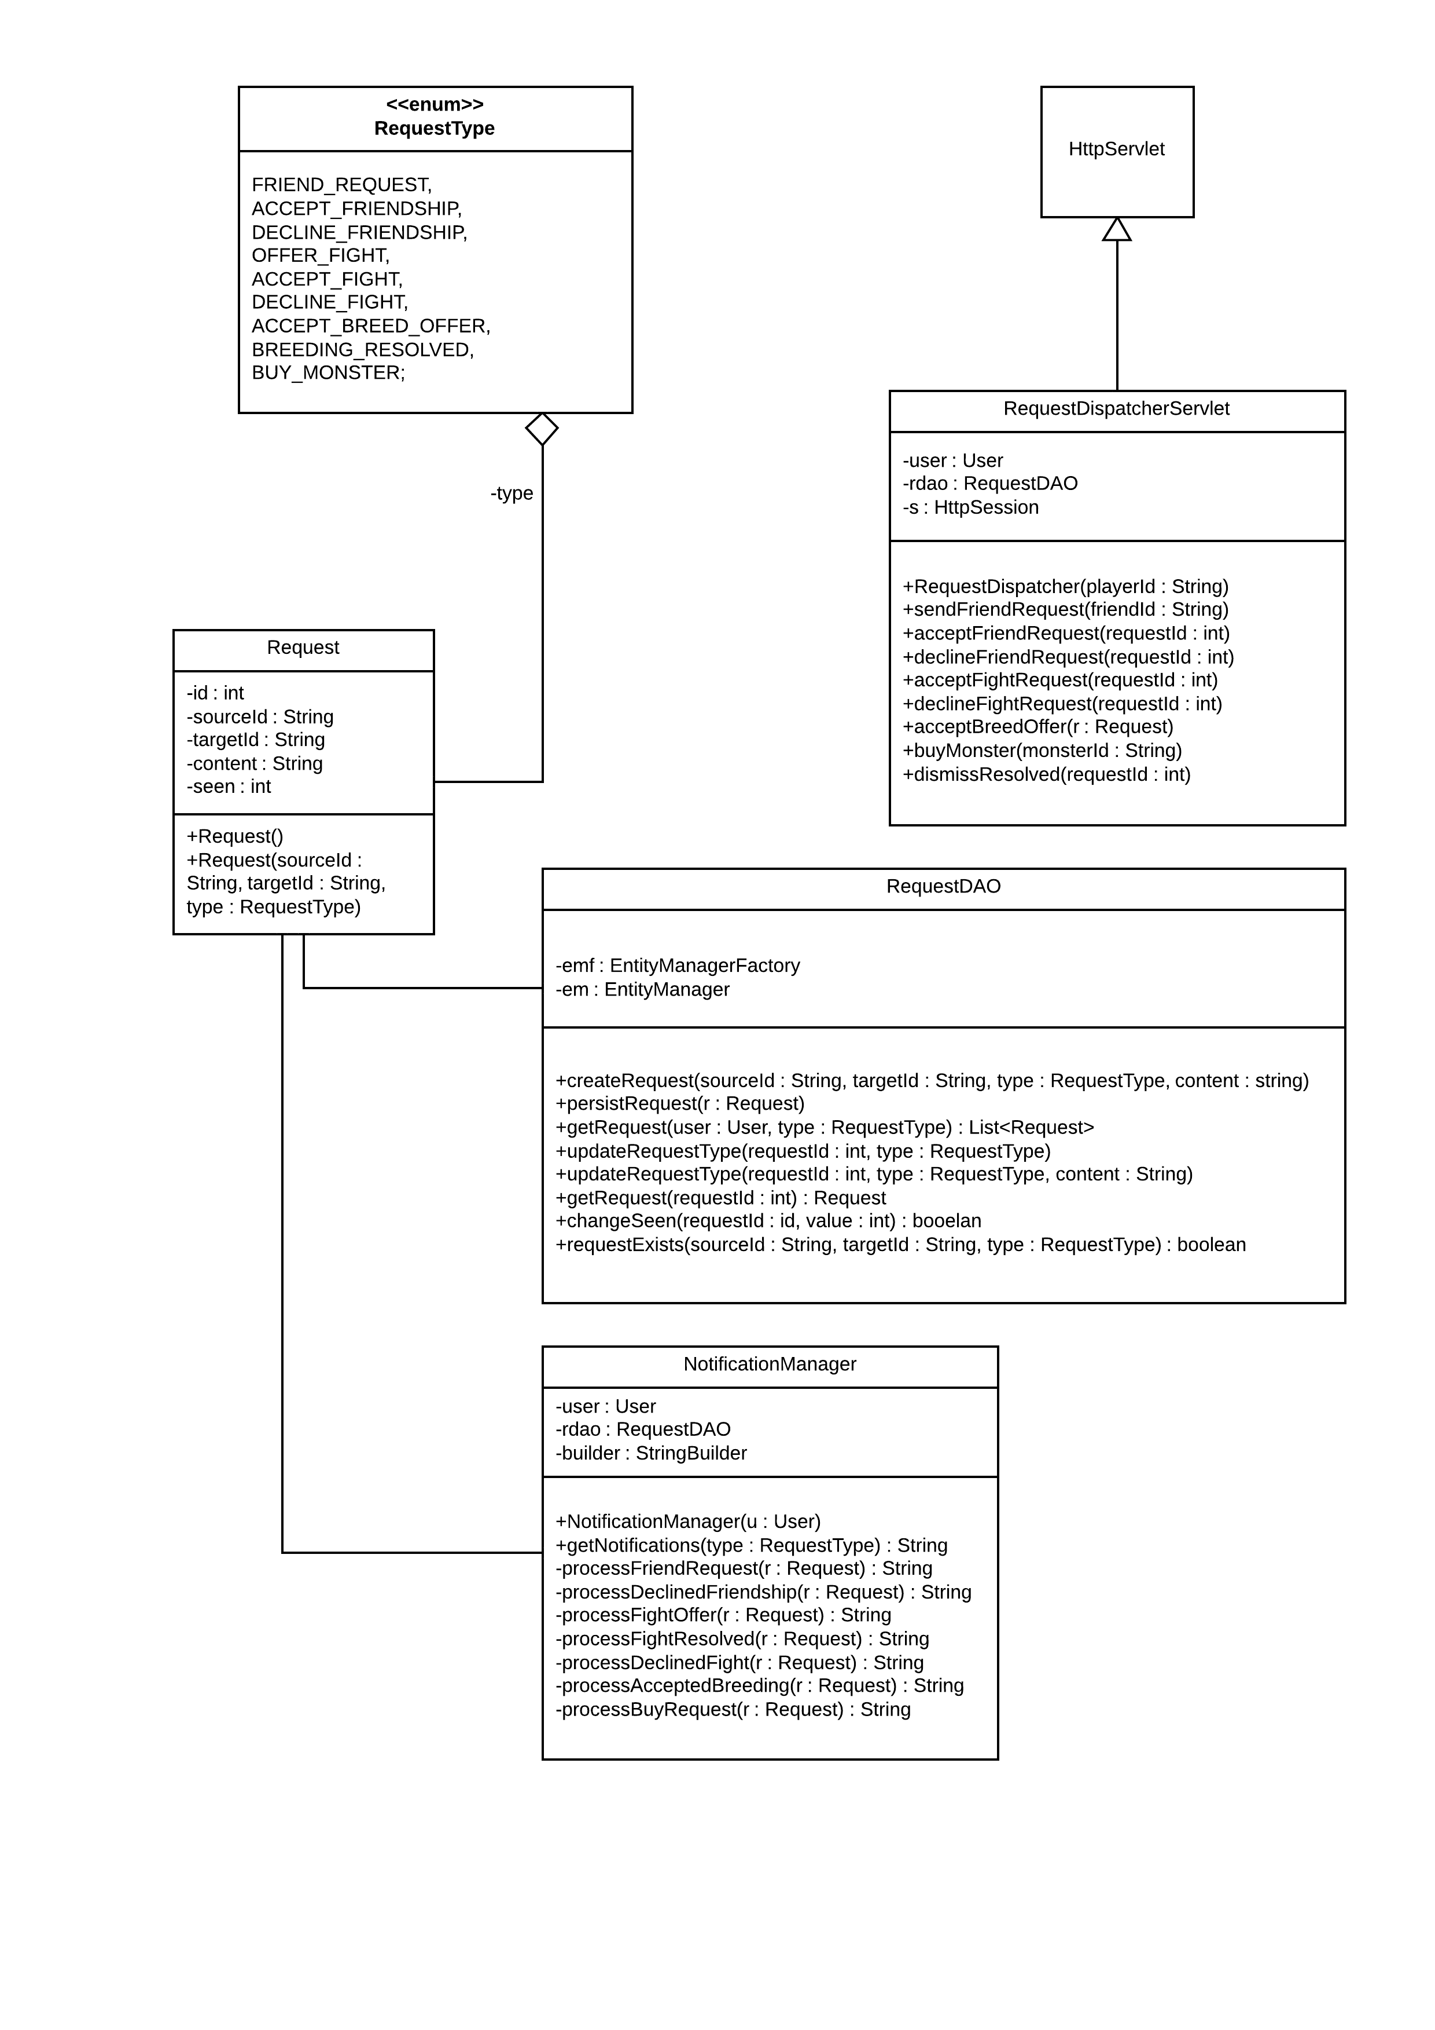

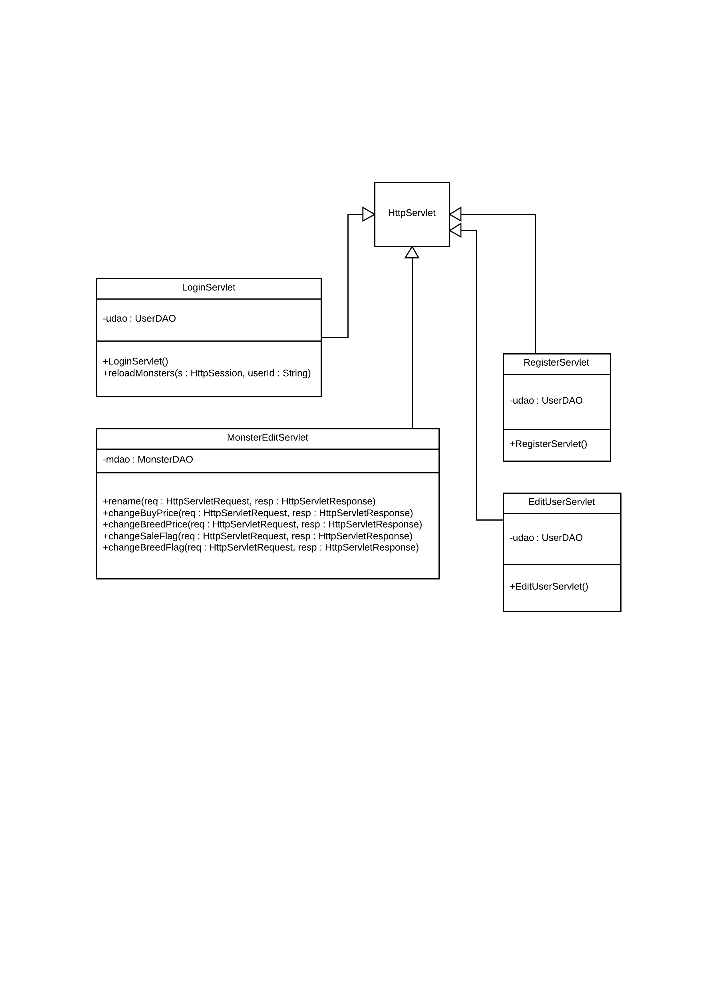

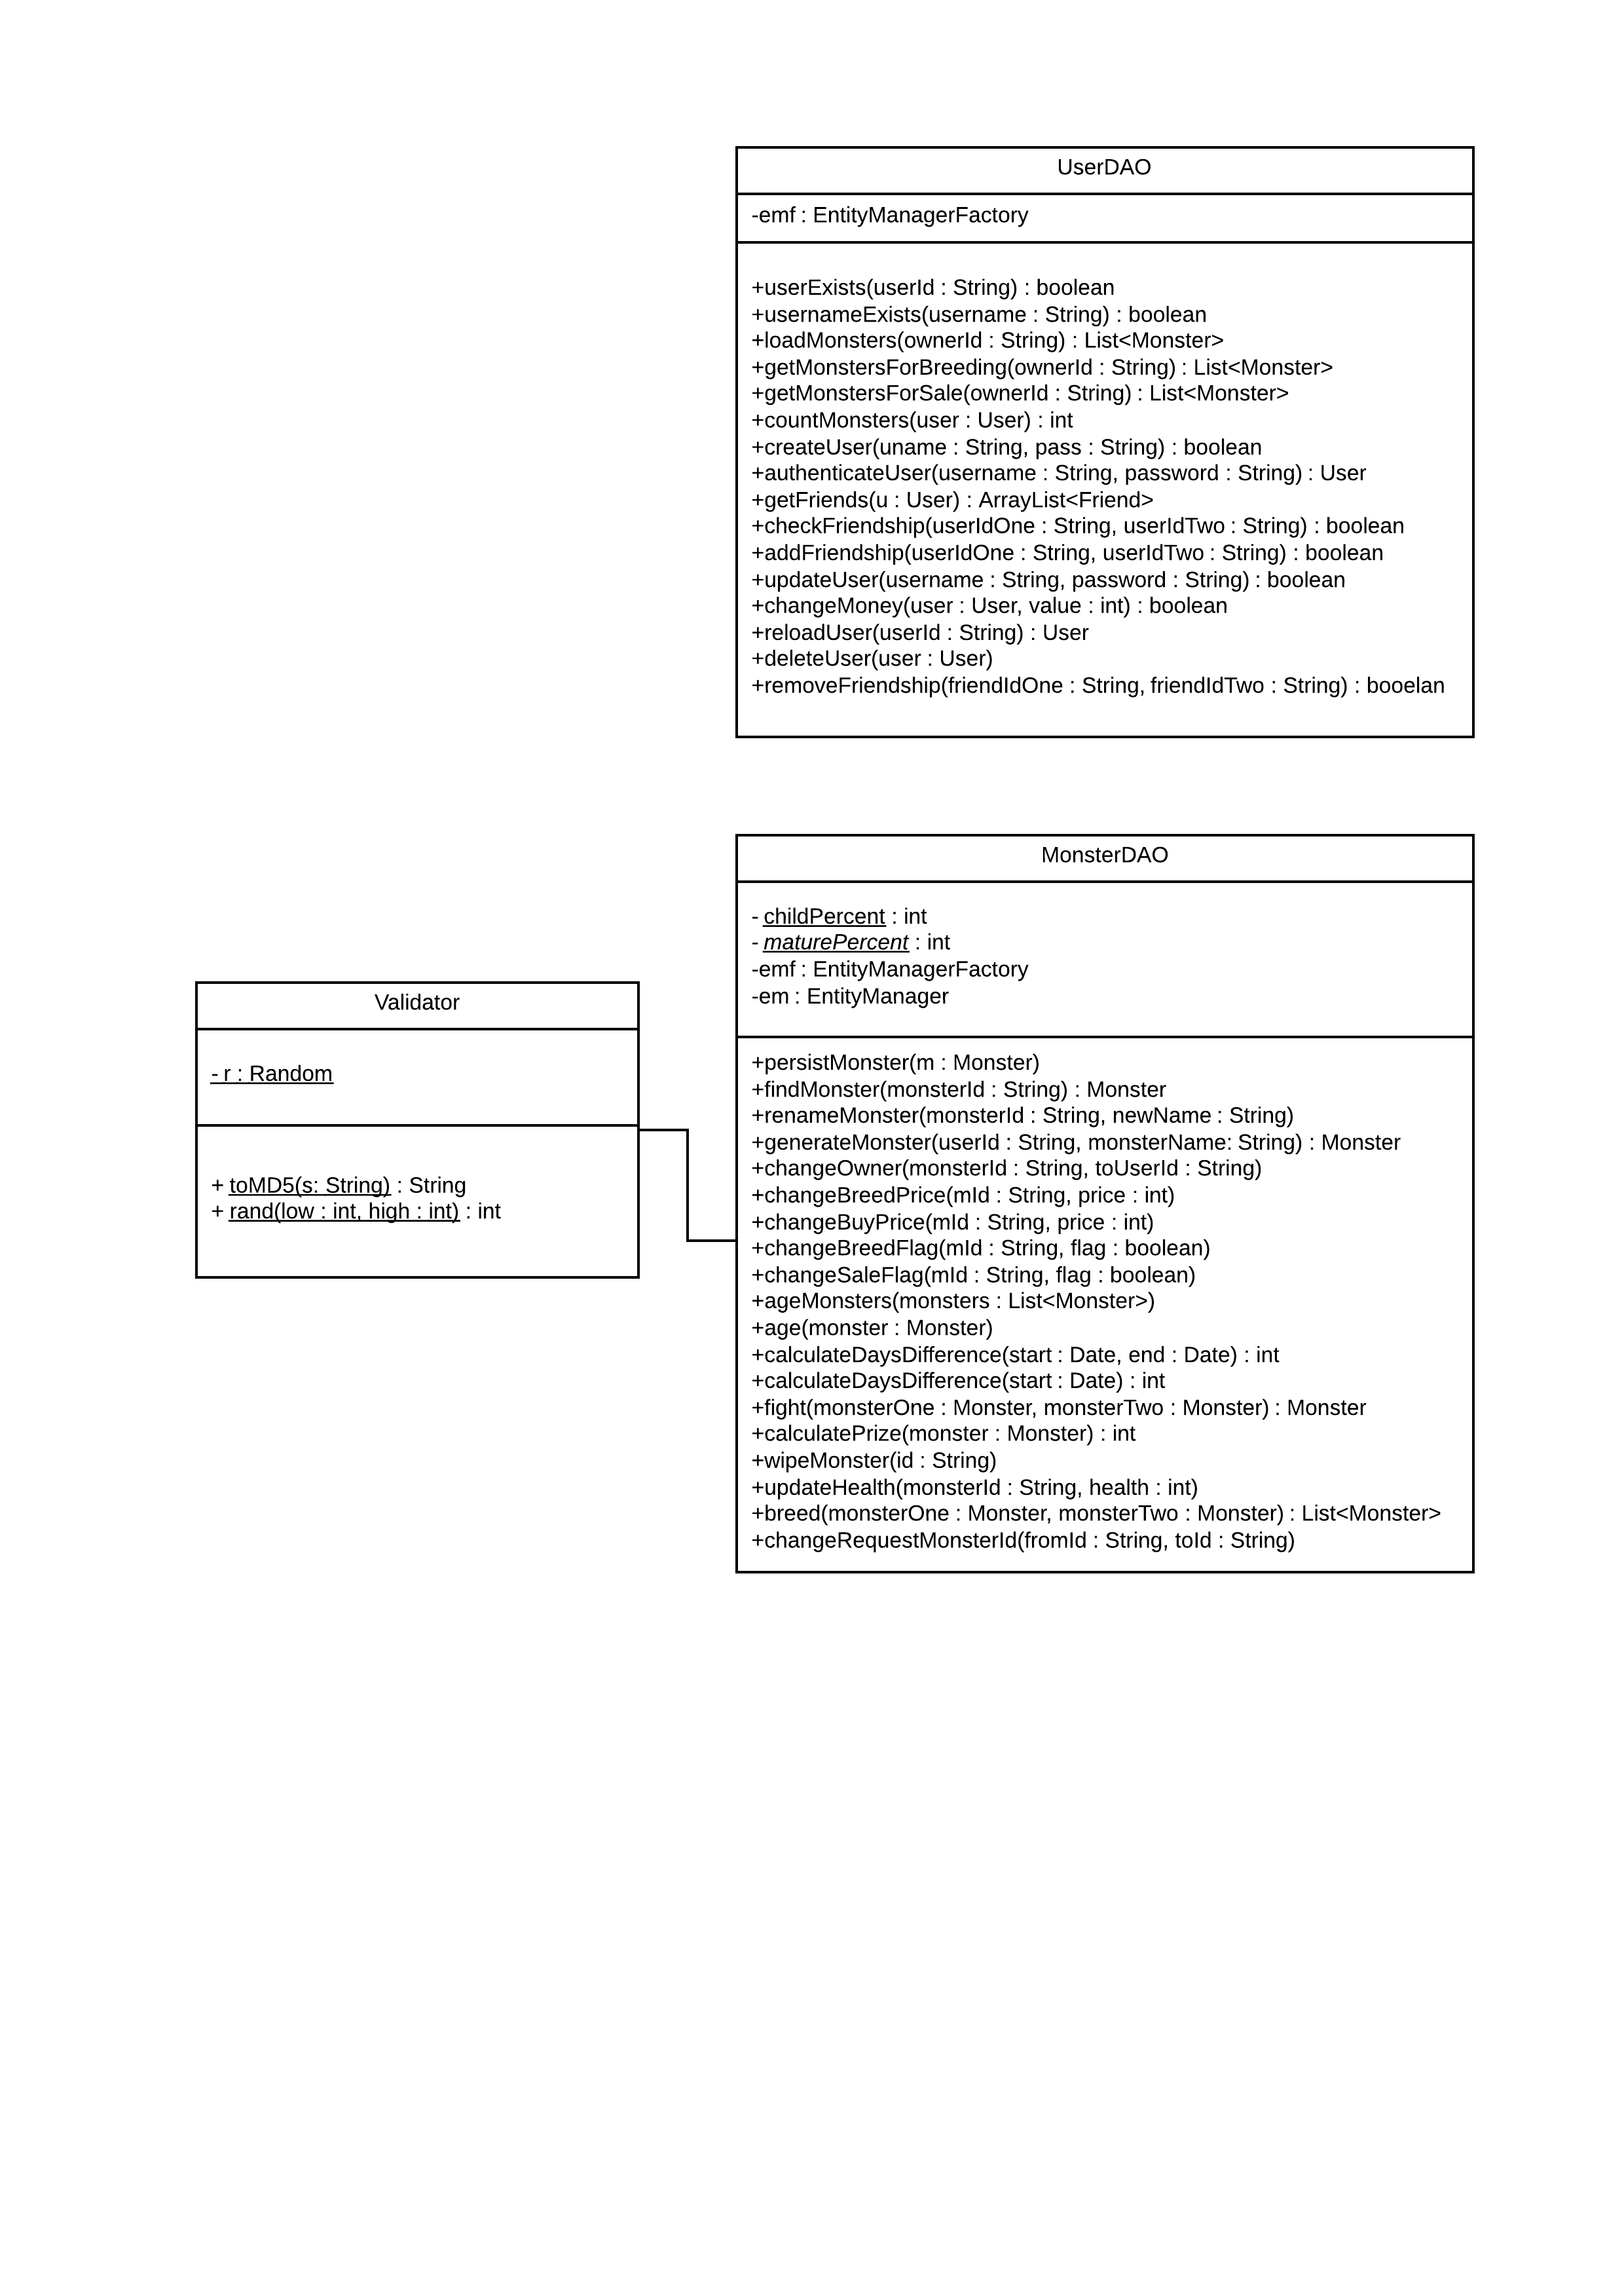

## Class Description

**Monster** – This class contains the attributes of the monster and methods to set monsters for breeding or for sale.

**User** – This class contains the details of the user, including username and password required to log them in. It also contains variables for the amount of money they have and their list of friends. It contains methods to set the password, get money (when account is created, by winning fights, selling, buying and breeding monsters), adding friends and deleting friends, adding monsters (by buying or breeding) and deleting monsters (when they lose fights or die of old age).

**UserDAO/User** – These classes manages the user accounts. It contains methods to create an account, remove an account, reset an account and authenticate the user and contains methods to obtain data from the server

**MonsterDAO/Monster** – These classes manages all methods when fetching and manipulating data from the database. It has certain functions, which are vital to the monsters fighting statistics, such as *age()*, but then also has certain methods for fighting and breeding monsters.

**RequestDAO/Request** – These classes manage all data manipulation when it comes to finding, creating or deleting requests from the database, and assigning them to different Users/Monsters

**RequestDispatcherServlet** – handles all input for setting up requests for monsters to fight/breed or be sold, while also serving as a point for users to add friends. It has been designed in such a manor that a simple layer on top to parse JSON is only needed for manipulating incoming/outgoing data.

## Mapping from requirements to Classes

|  |  |
| --- | --- |
| **Requirement** | **Classes providing requirement** |
| FR1 | AccountManager |
| FR2 | DataManager, Friend |
| FR3 | User, DataManager |
| FR4 | RequestDispatcher, FightRequest, FightResolver |
| FR5 | RequestDispatcher, Request |
| FR6 | AccountManager, User, Monster |
| FR7 | AccountManager, User, index.jsp |
| FR8 | JSP pages |
| FR9 | RequestDispatcher, friends.jsp |
| FR10 | FightResolver, FightRequest, fight.jsp |
| FR11 | DataManager |
| EIR1, PR1, PR2 | JSP Pages |

# Dependency Description

## Component Diagrams

# Detailed Design

## Sequence Diagrams

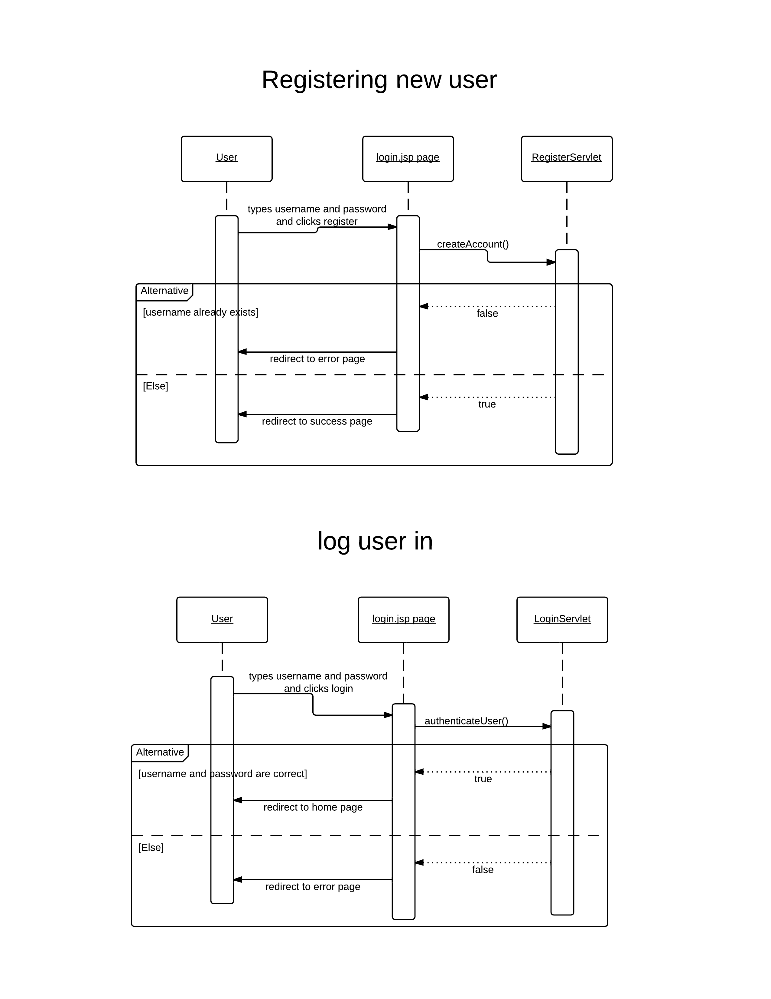

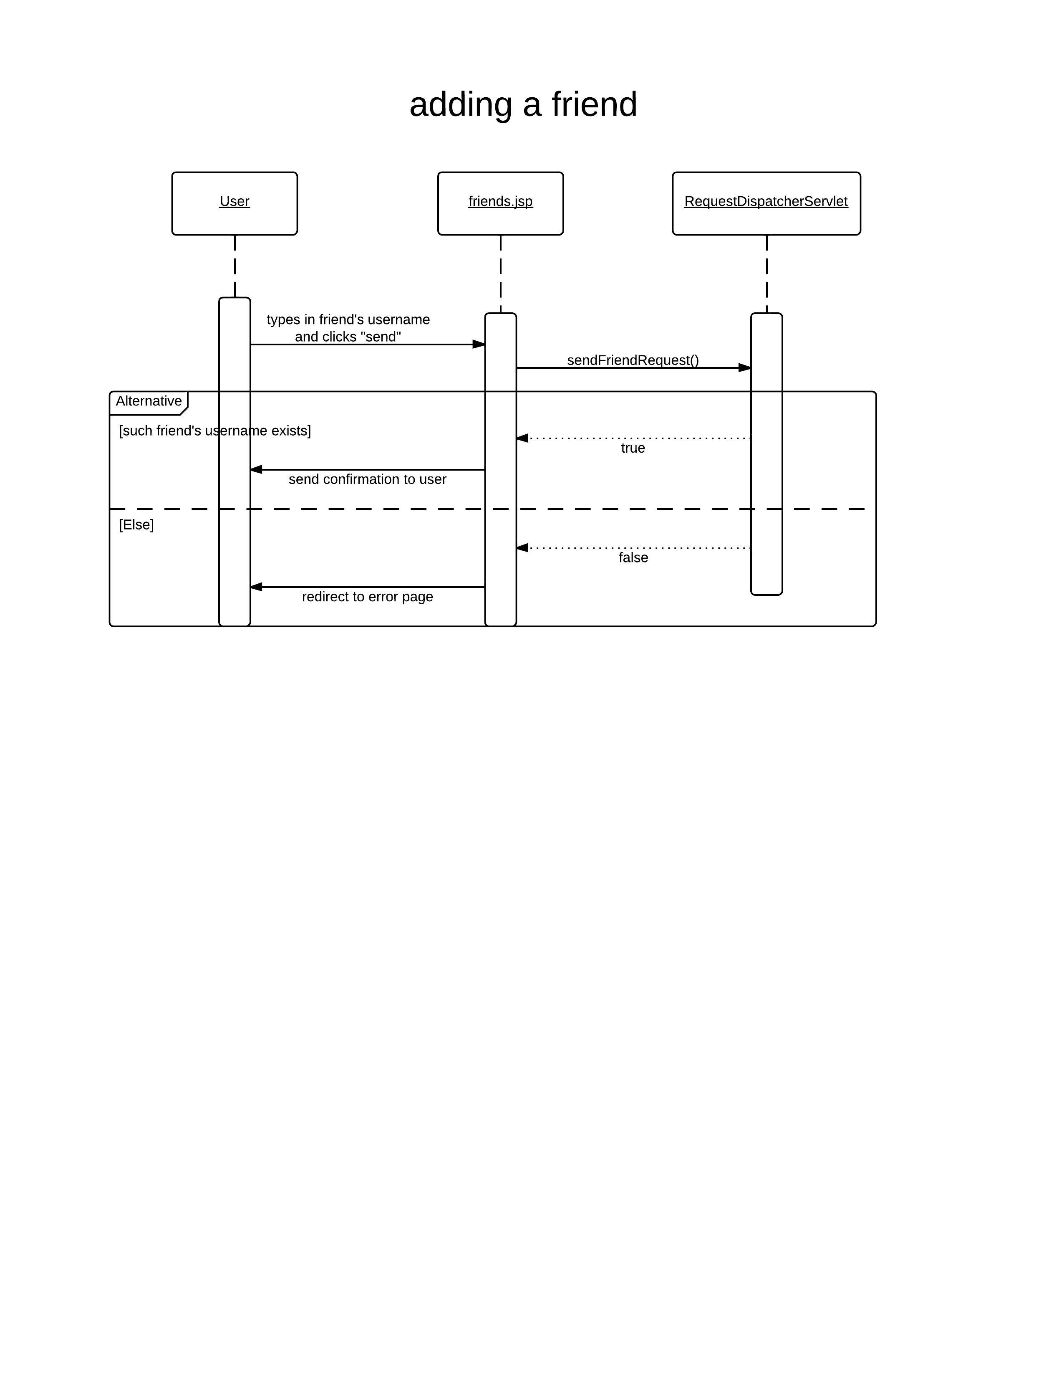

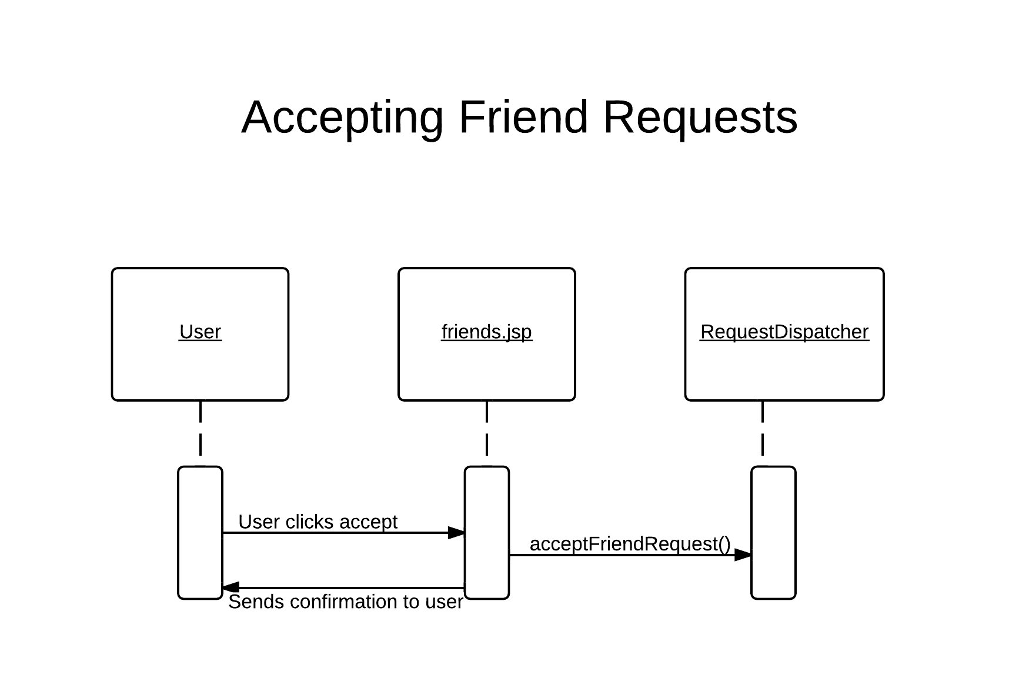



# Macintosh HD:Users:user:Downloads:BasicSequenceDiagram (2).png

# Macintosh HD:Users:user:Downloads:BasicSequenceDiagram (3).png

# Macintosh HD:Users:user:Downloads:BasicSequenceDiagram (4).pngChange log

|  |  |  |  |  |
| --- | --- | --- | --- | --- |
| Version | CCF Number | Date | What Changed | User |
| 1.0 | N/a | 02.12.2012 | First Draft | imm5 |
| 1.1 | N/a | 07.12.2012 | Brought up to standard. | cew10 |
| 1.2 | N/a | 30.01.2013 | Proofread and corrections | cew10 |
| 1.3 | N/A | 14/02/2013 | Updated with new design | Sbs1 |